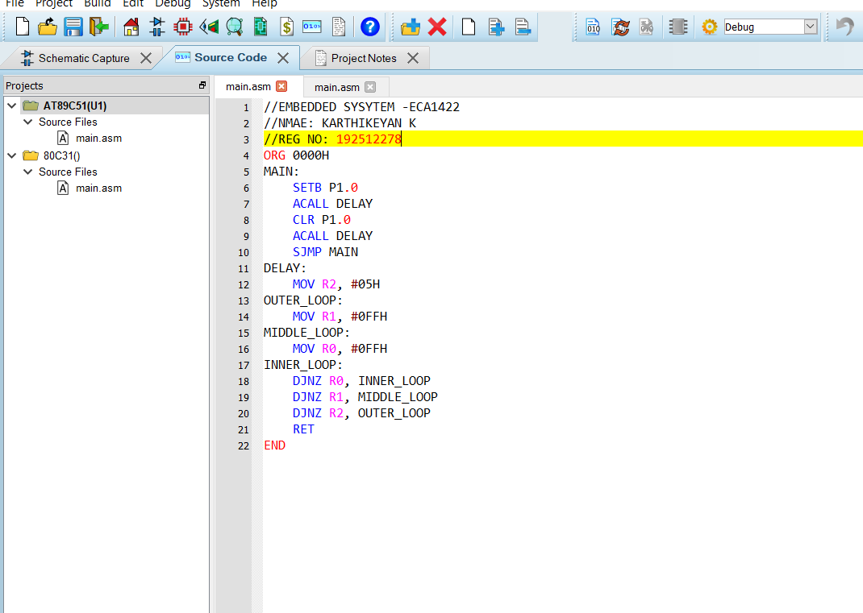
1 Flashing of Led using AT89C51 Microcontroller using Proteus

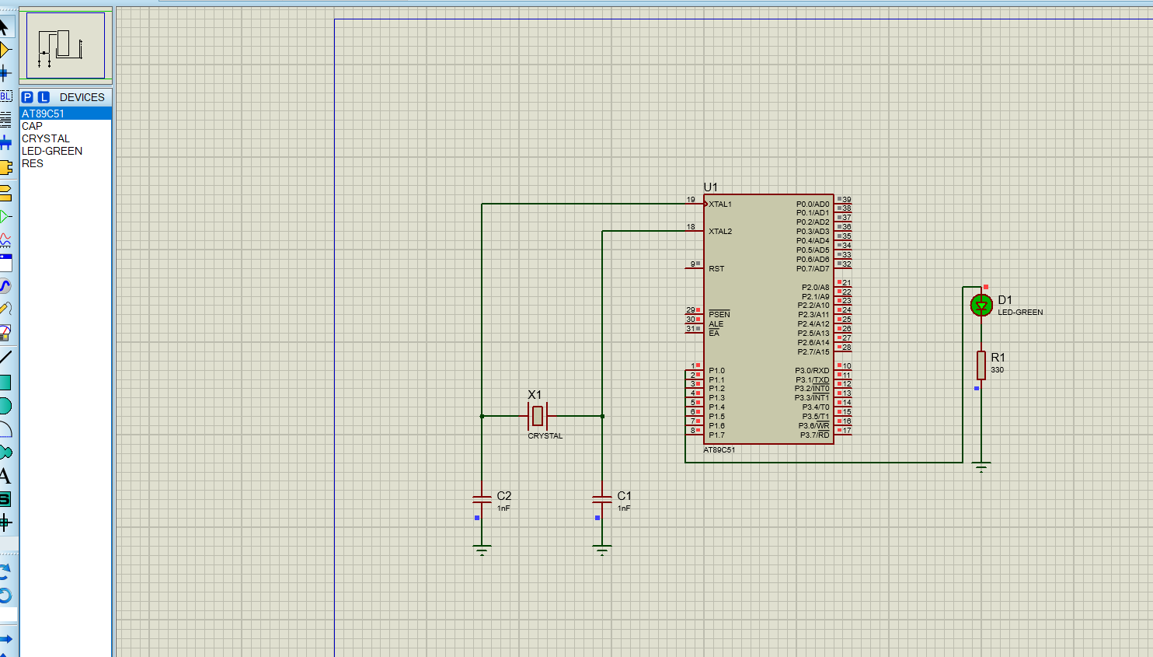

2 Generation of Square Wave using Proteus
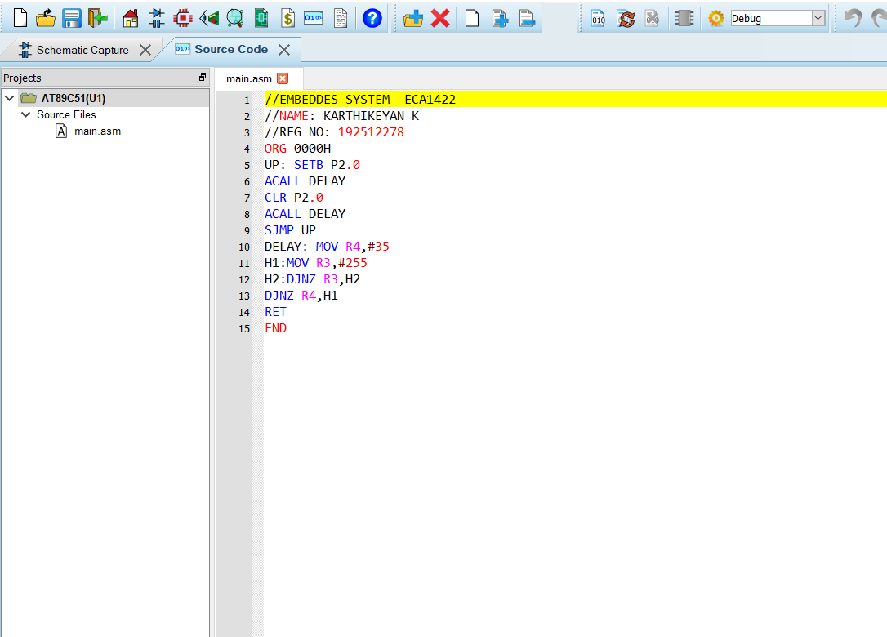

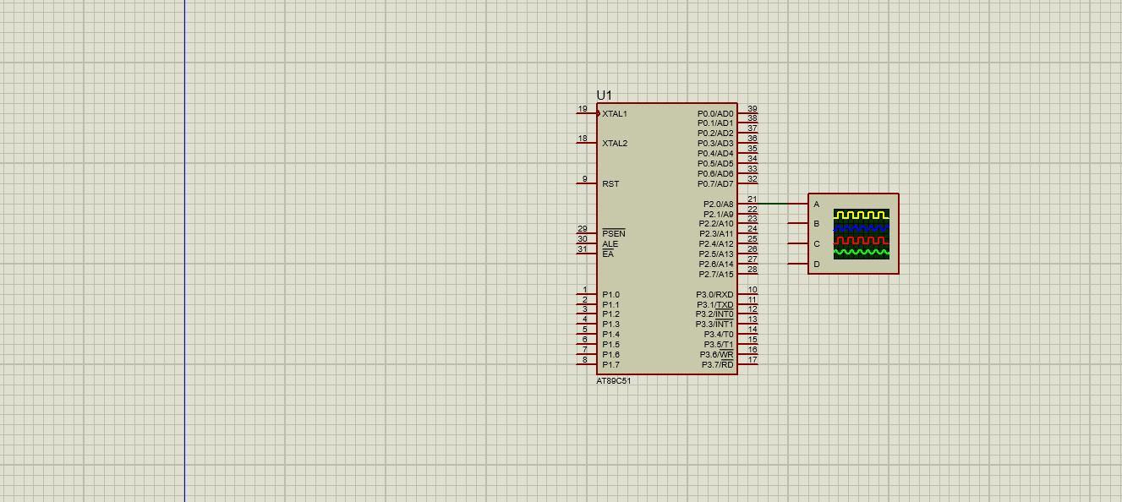

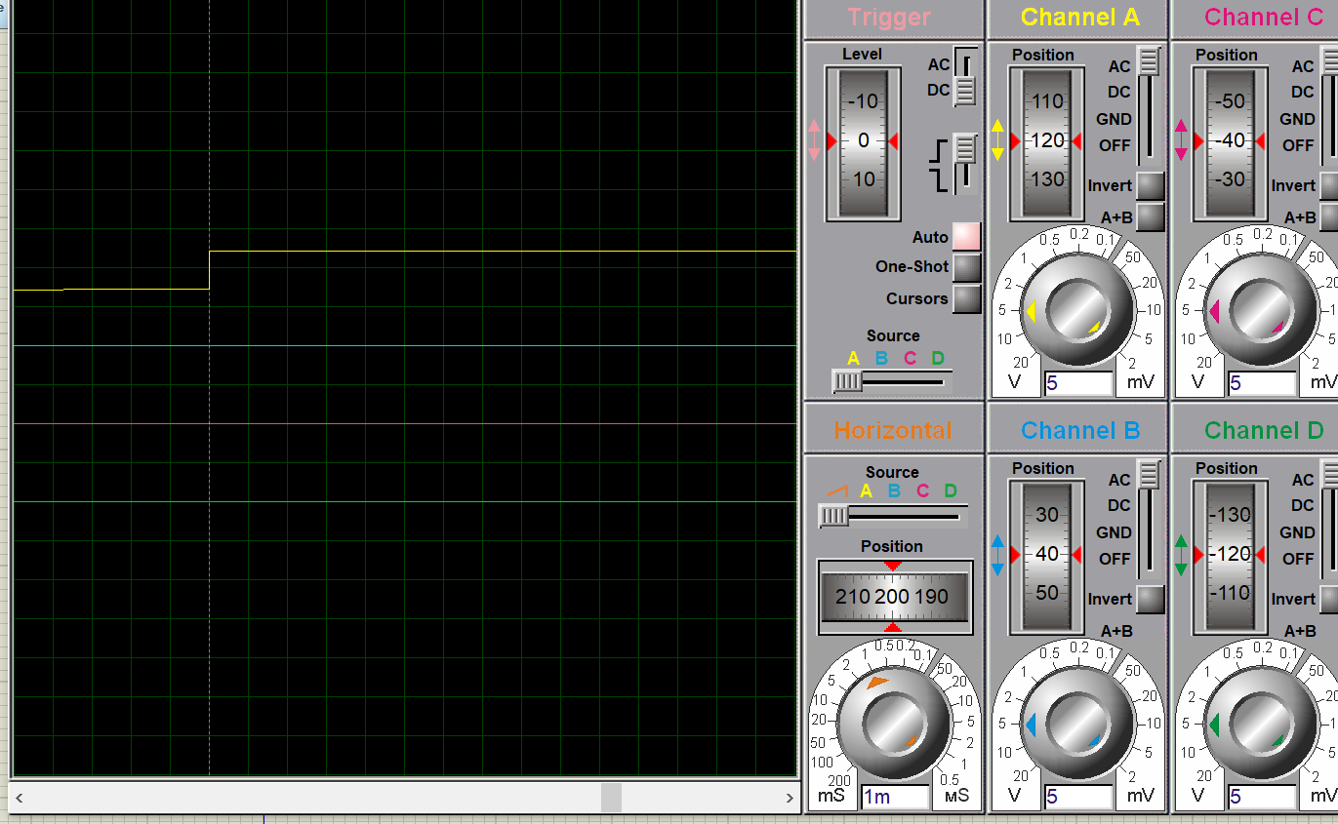
3 Stepper Motor Using AT89C51 using Proteus
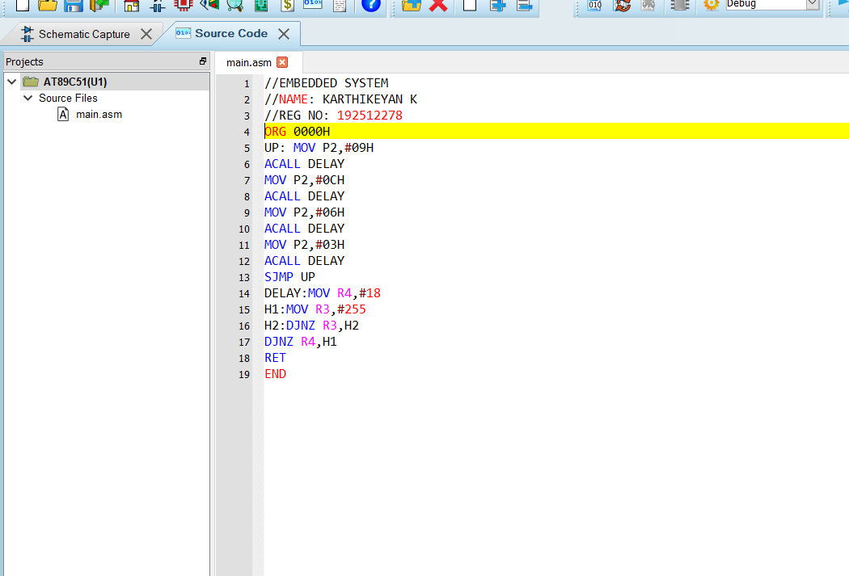
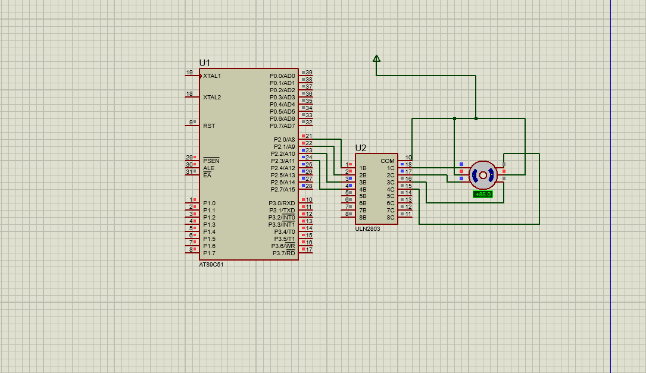

4 7 Segment Display Using AT89C51 using Proteus
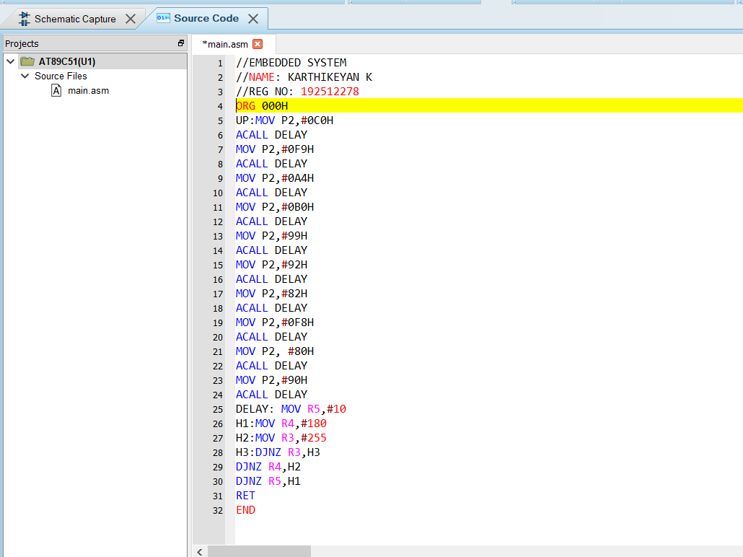

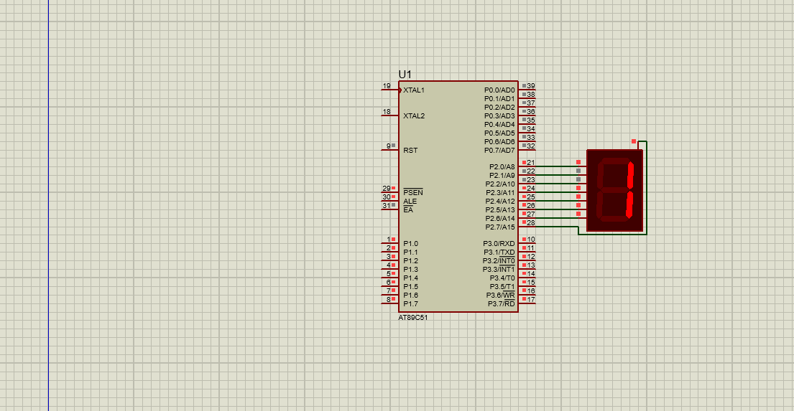

5 Arduino based Manual Electronic Counter using Proteus
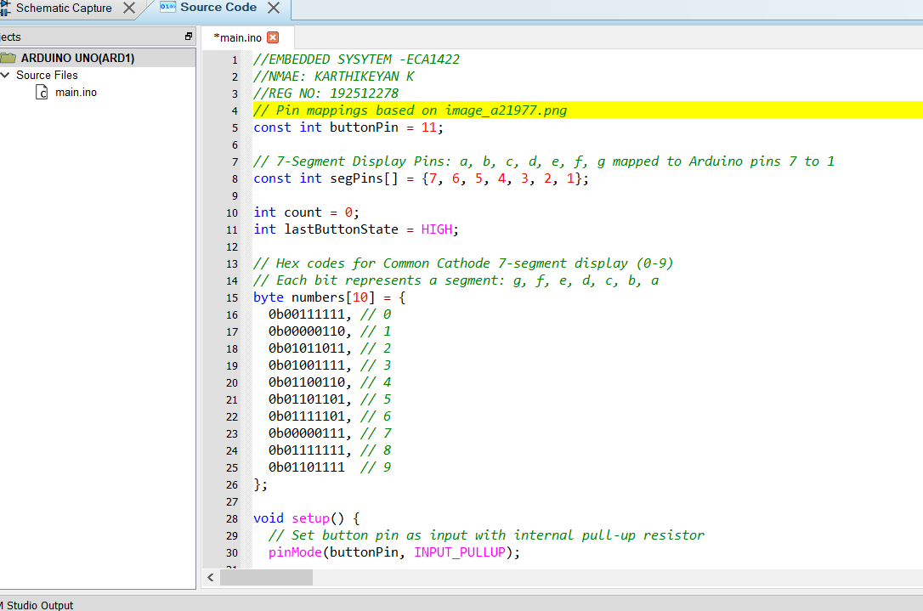

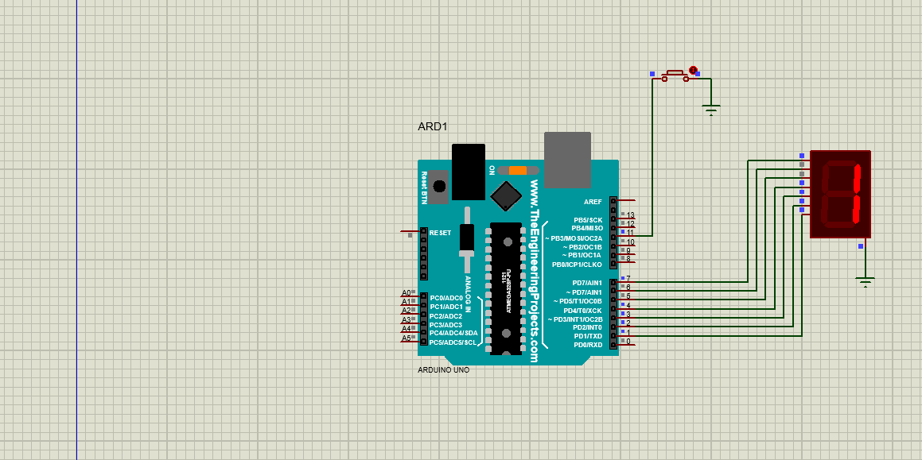

6 Arduino to 16x2 LCD Display using Proteus
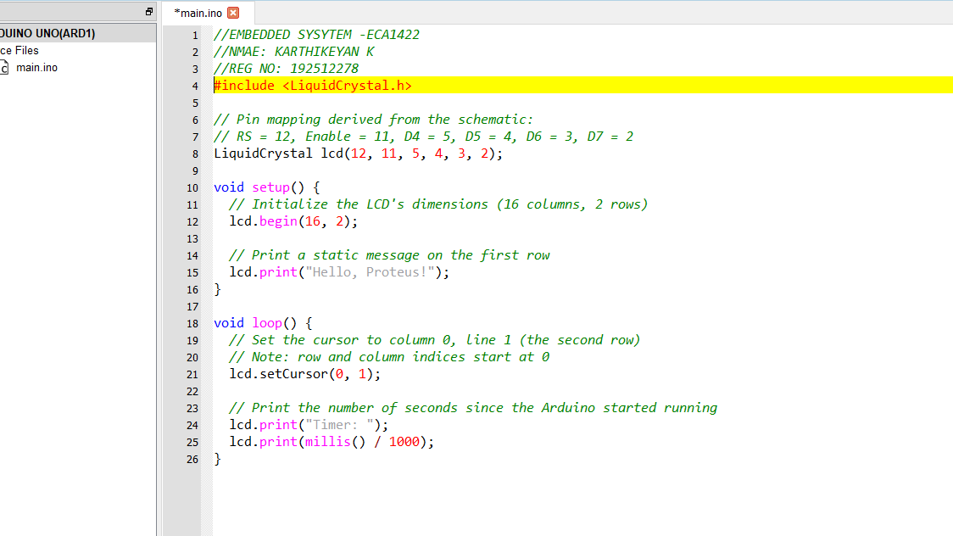

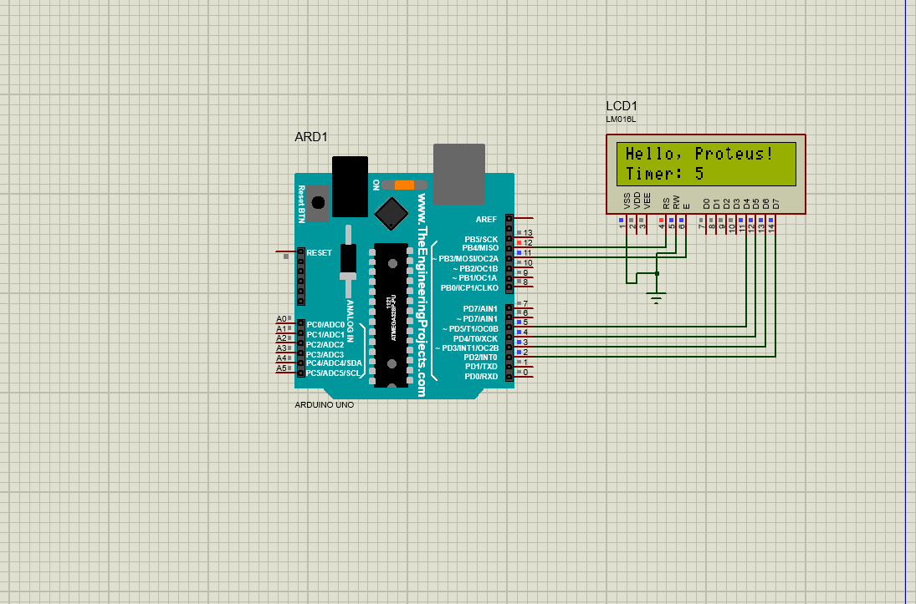
7 Serial Communication using Arduino with Proteus
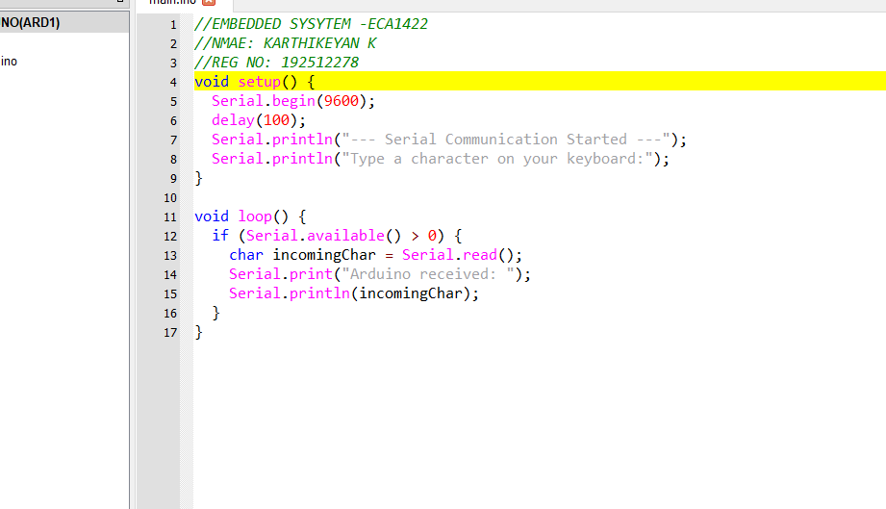

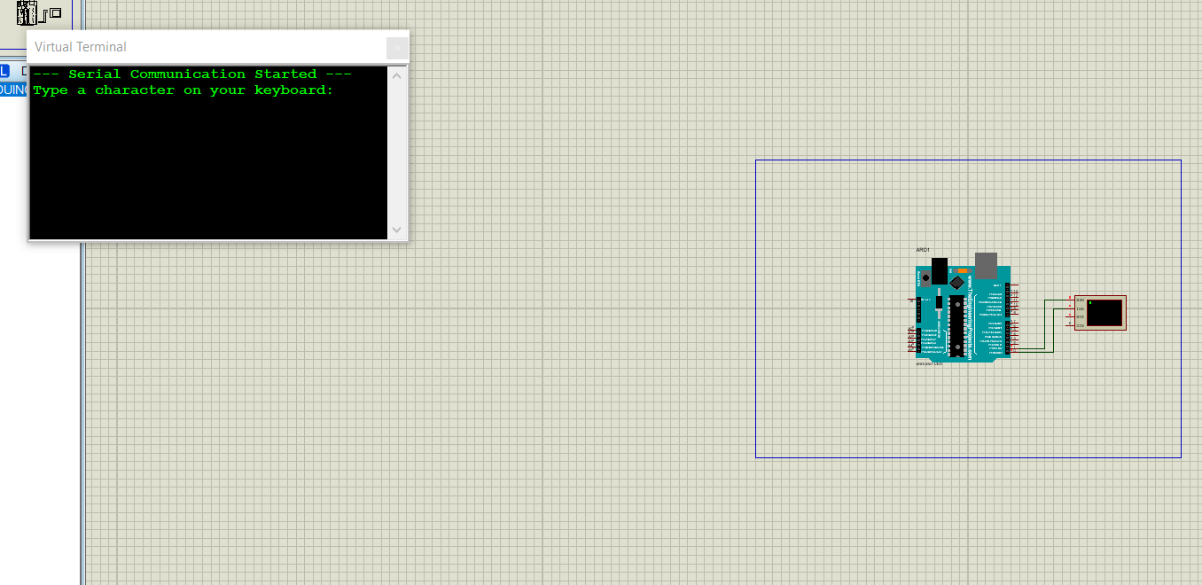

8 Gas Sensor MQ-2 in Proteus using Arduino
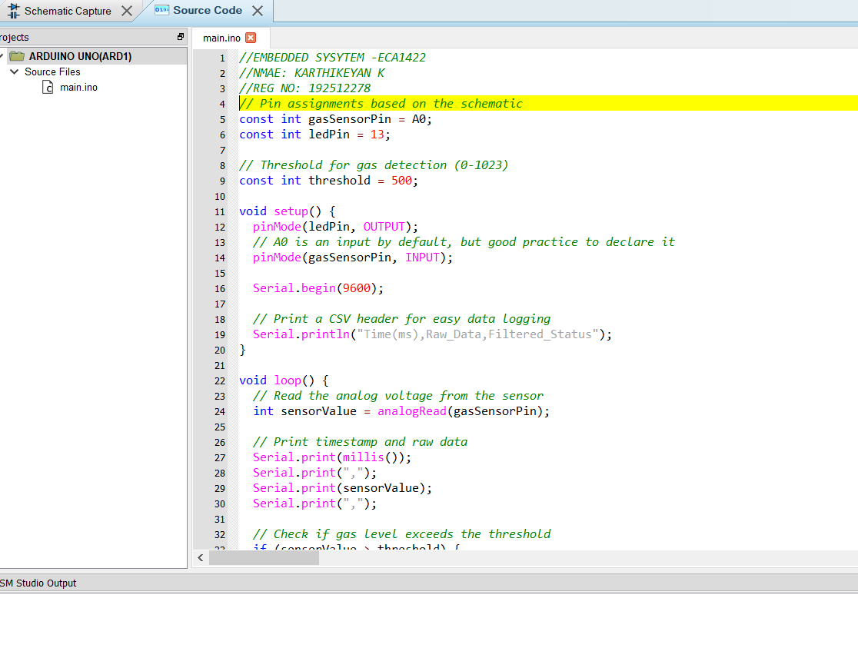

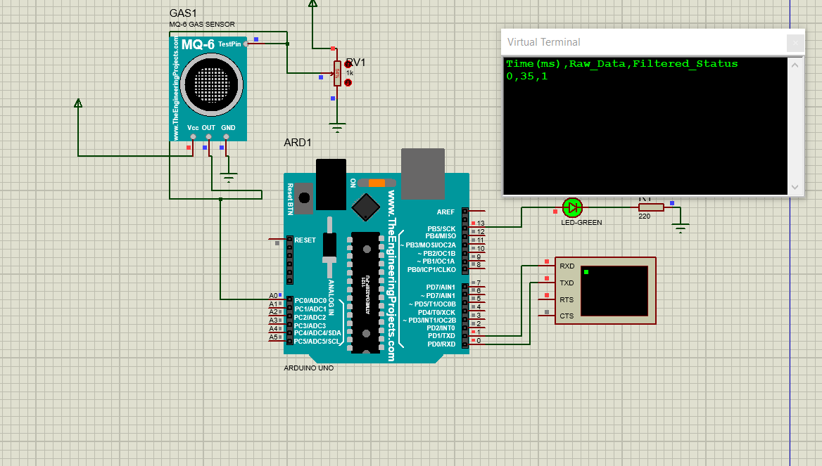

9 Ultrasonic Sensor in Proteus using Arduino
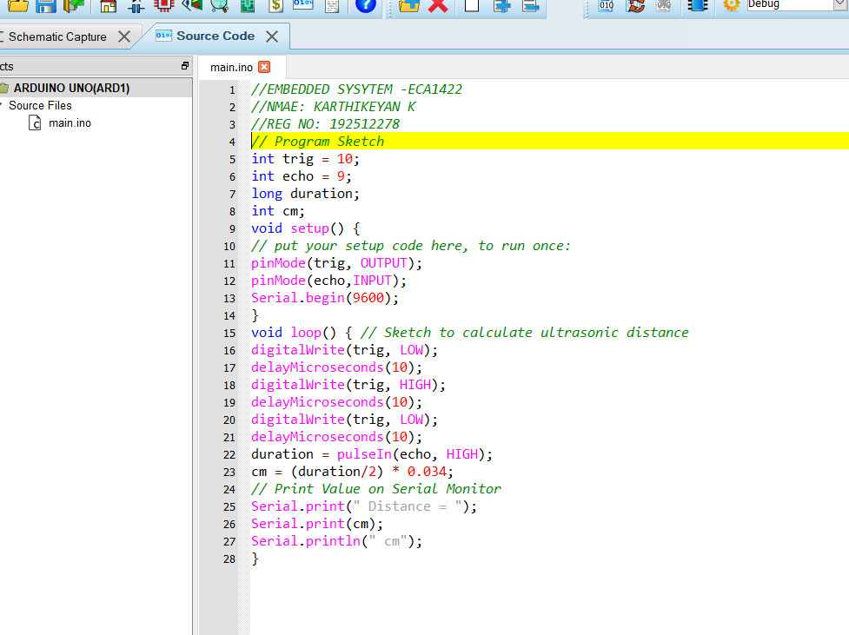

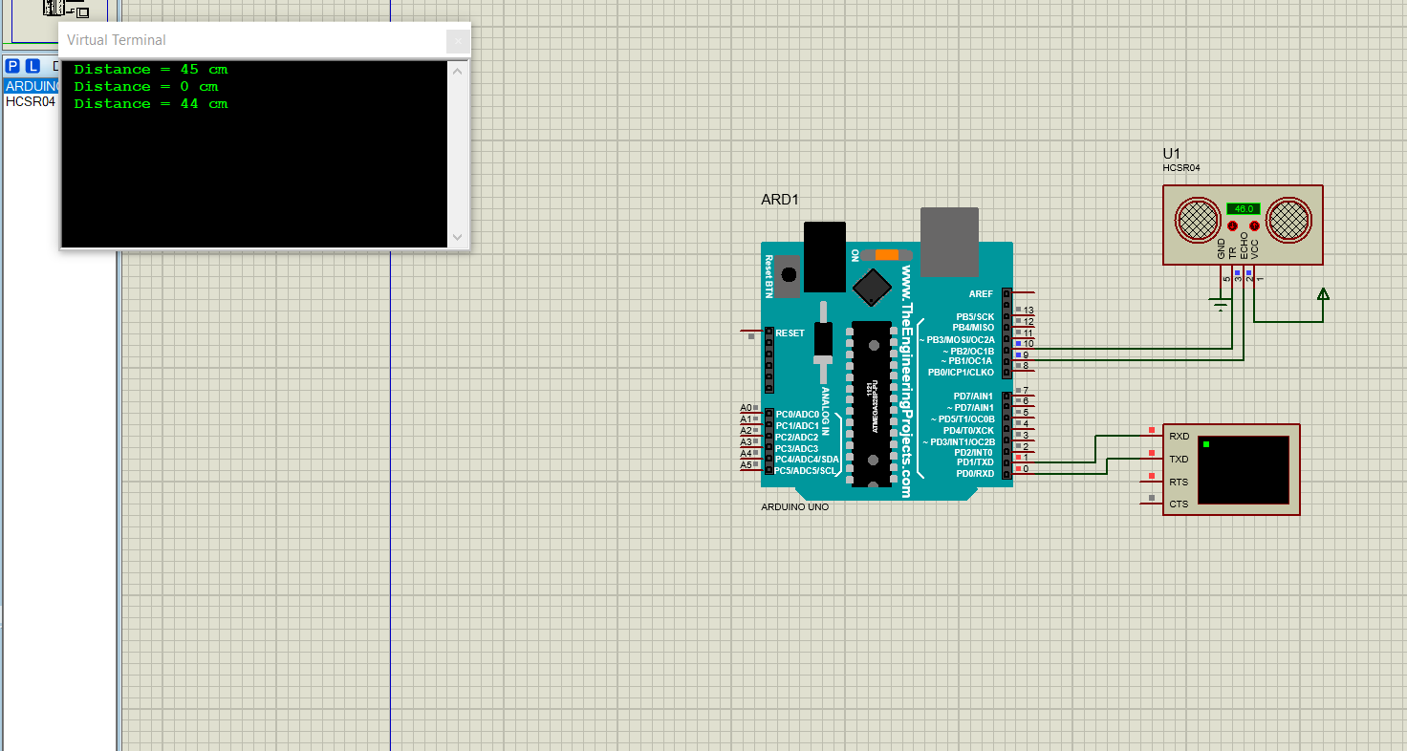
10 PIR Sensor in Proteus using Arduino
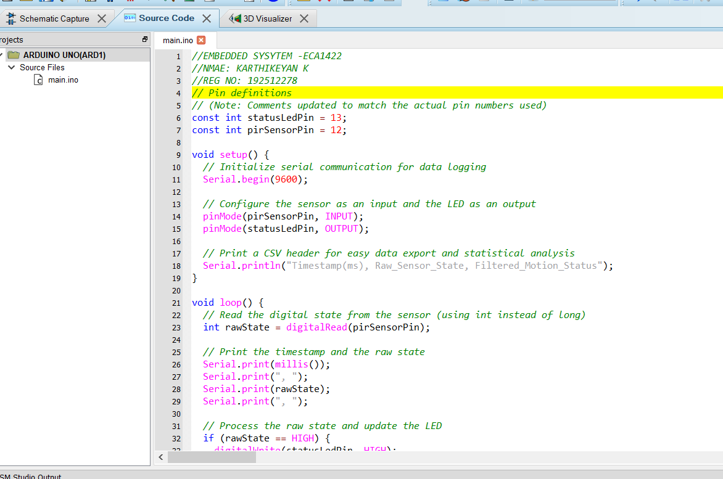

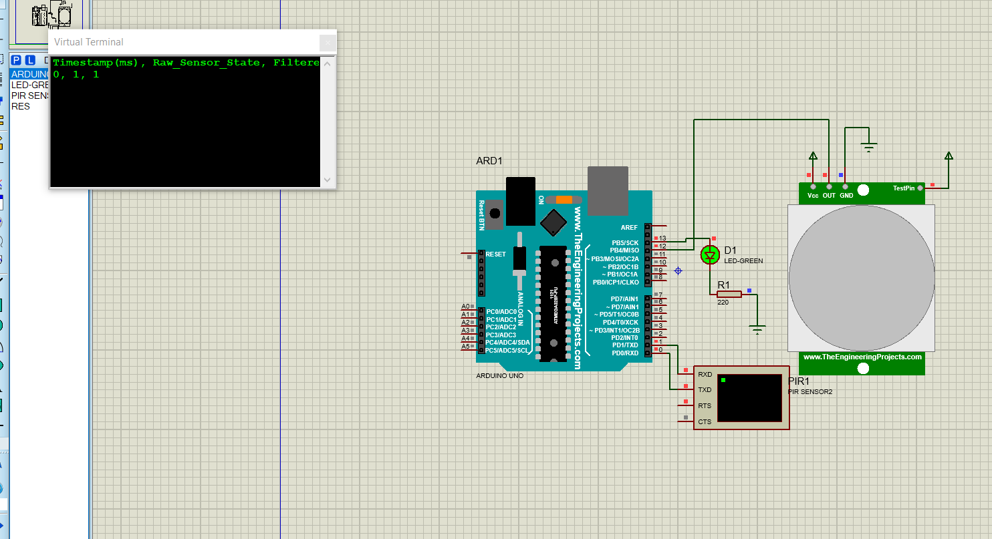

11 Study of GPIO & Bit Addressing in AT89C51 using Embedded C
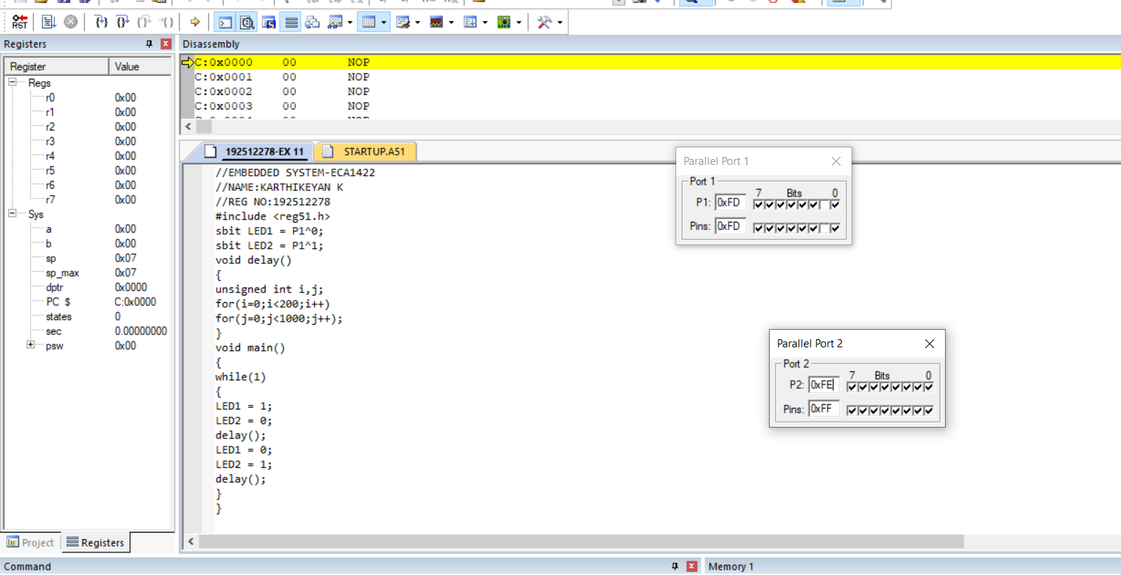

12 Embedded C program to multiply two 16-bit binary numbers.
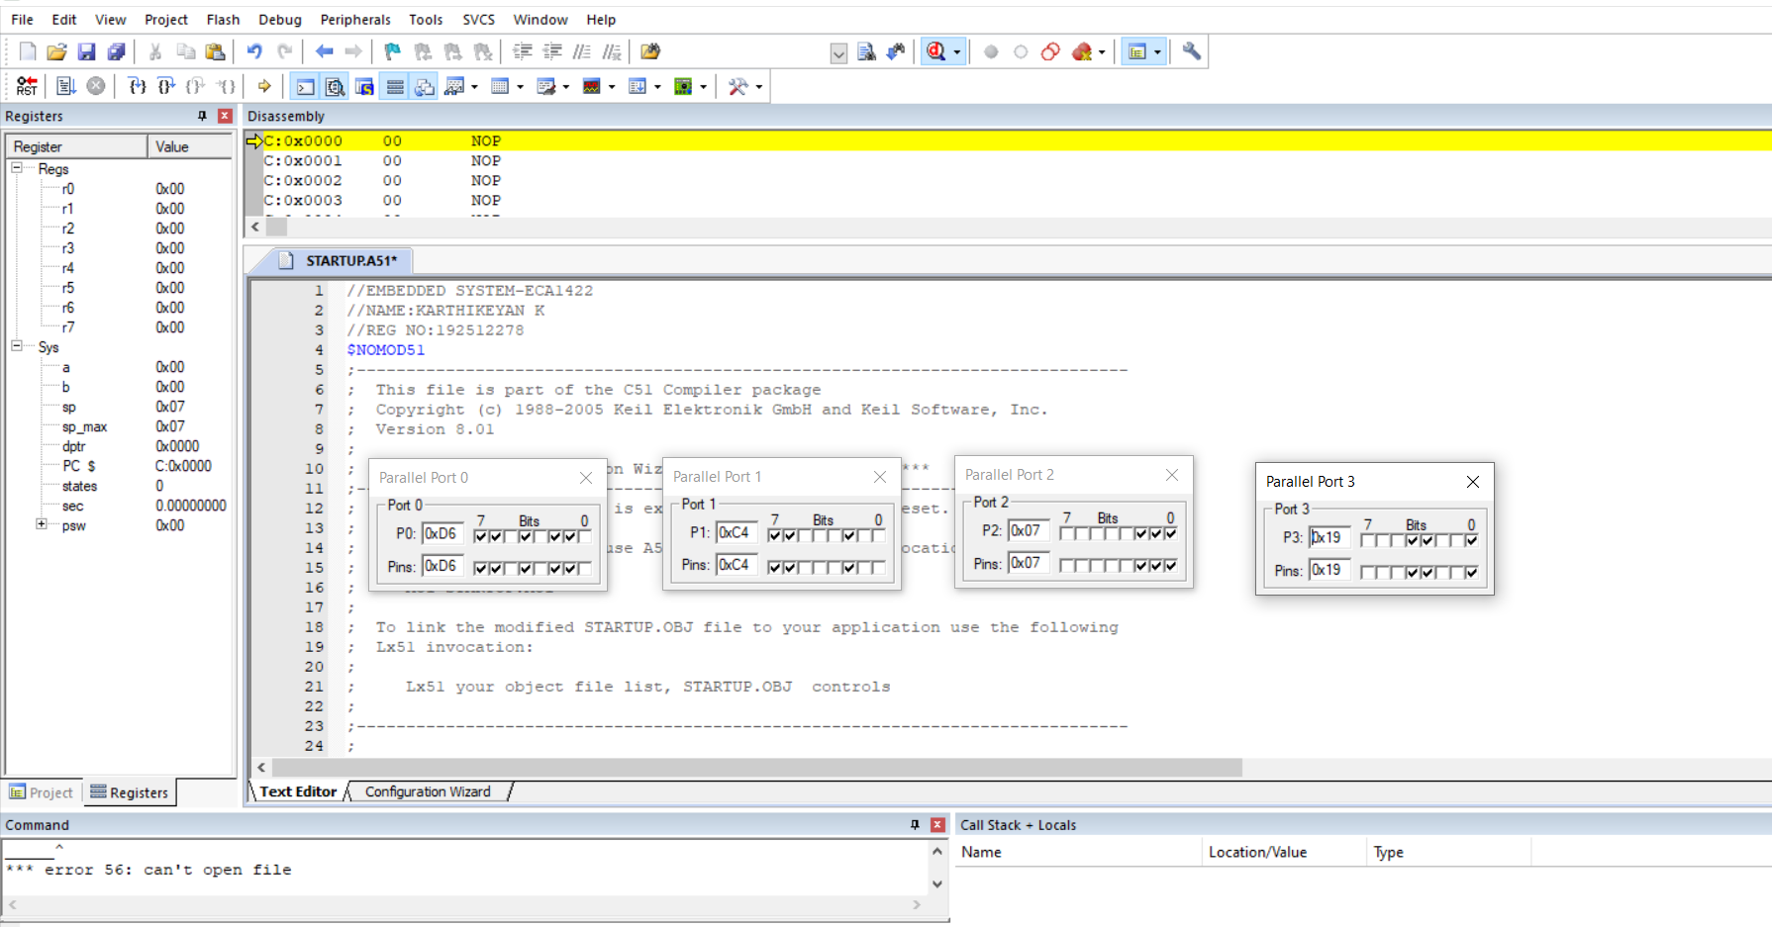
13 Embedded C program to add an array of 16-bit numbers and store the 32-bit result in internal RAM.

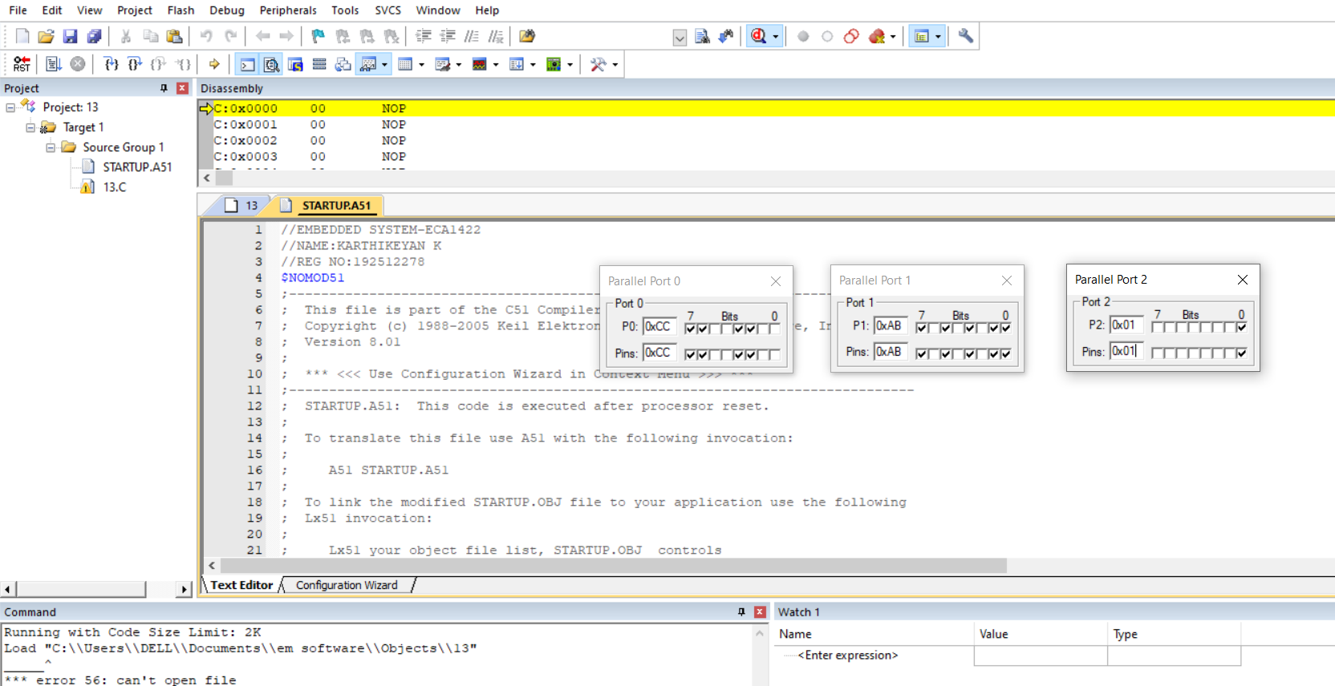

14 Embedded C program to display “Hello World” message
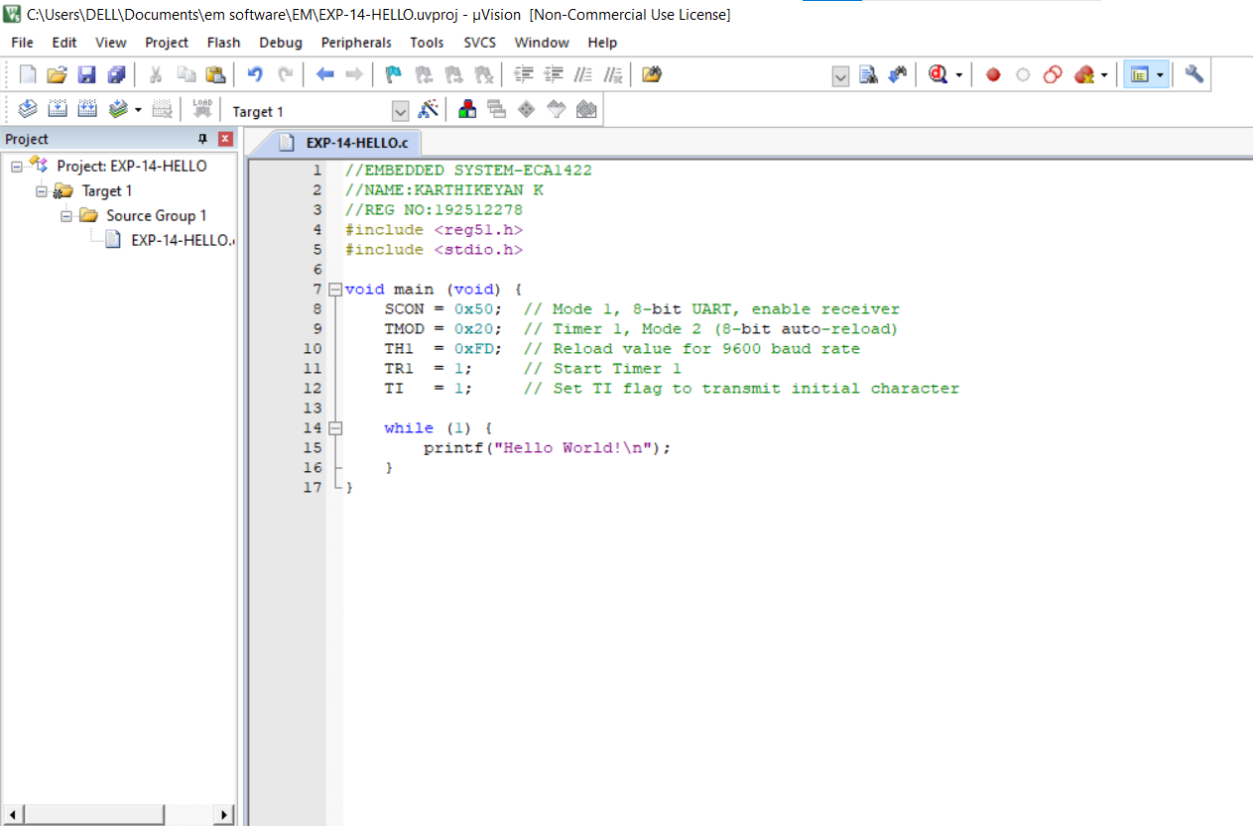
15 Embedded C program to convert the hexadecimal data to decimal and display the digits on ports P0, P1 and P2

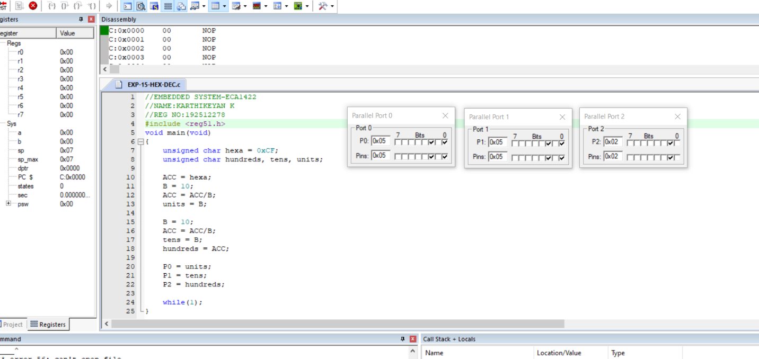

16 Serial Interrupt Using UART (Keyboard Input) In Keil
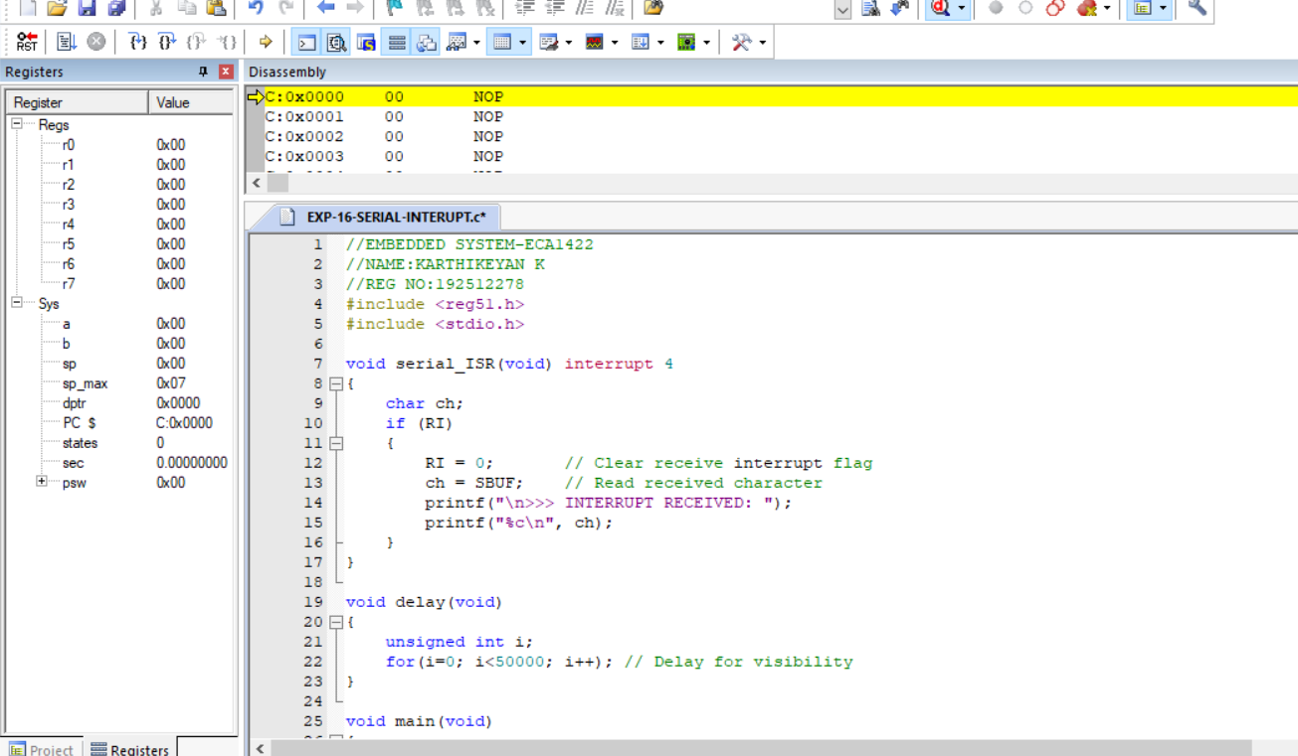

17 UART Interfacing using Interrupt in KEIL
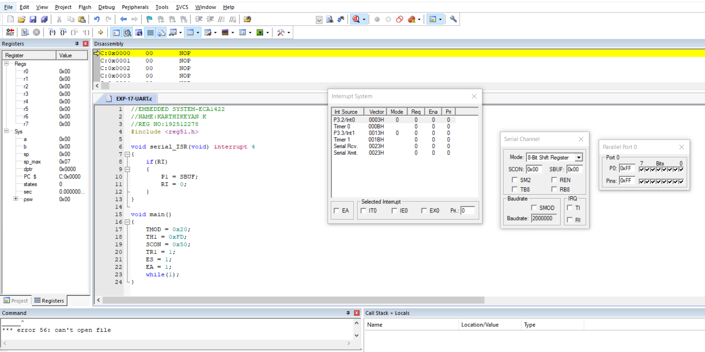

18 Generation of PWM using TIMER Interrupt
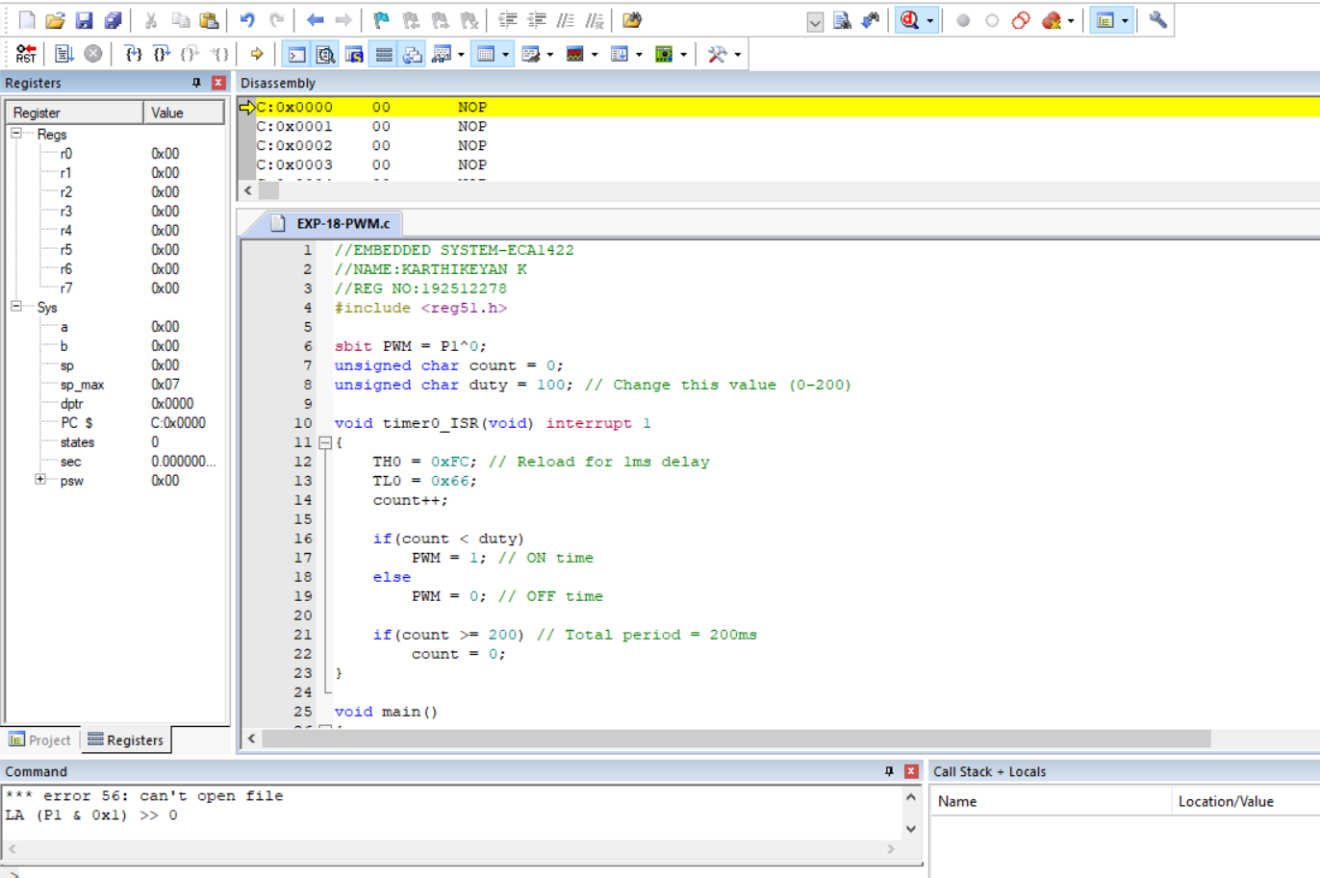
24 Modeling Clock-Driven Concurrent Processes Using
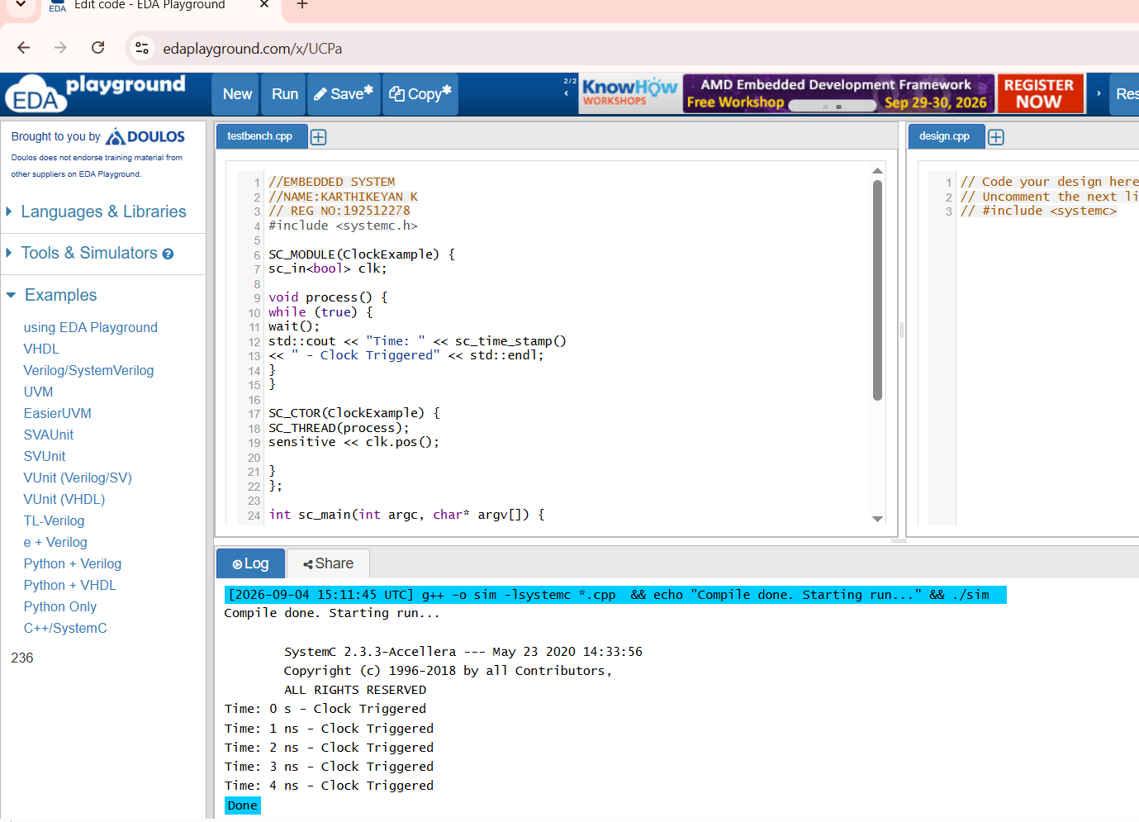
SC_THREAD and wait() in SystemC

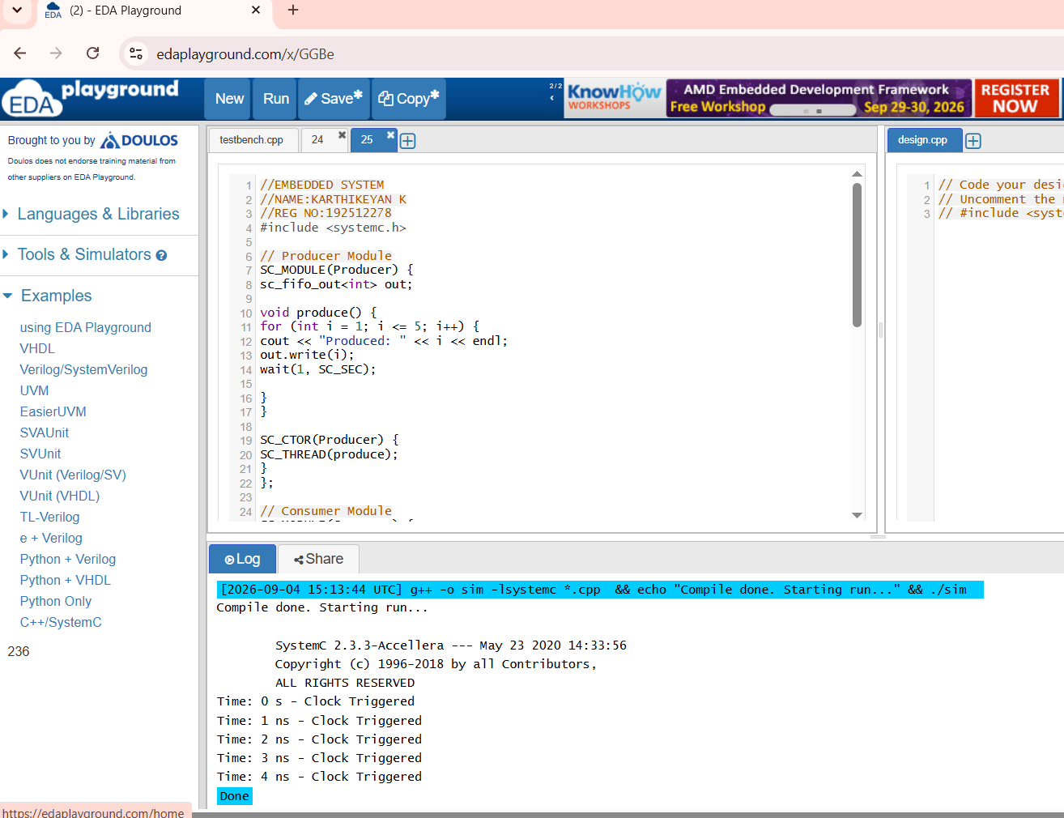
25 Producer–Consumer Problem Using SystemC
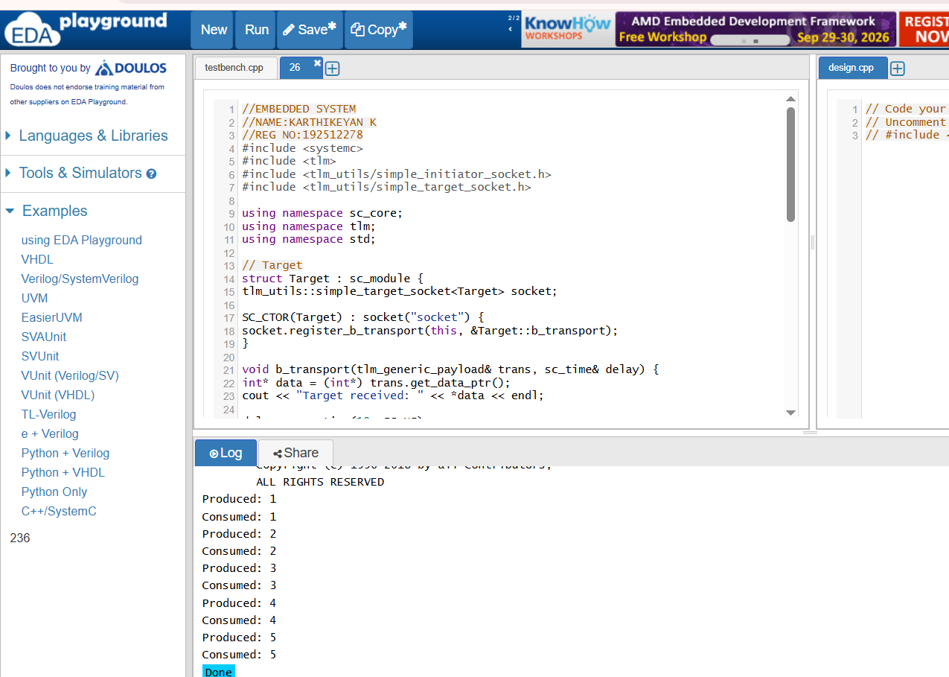
26 Transaction Level Modeling (TLM) using SystemC

27 Binary Semaphore in SystemC
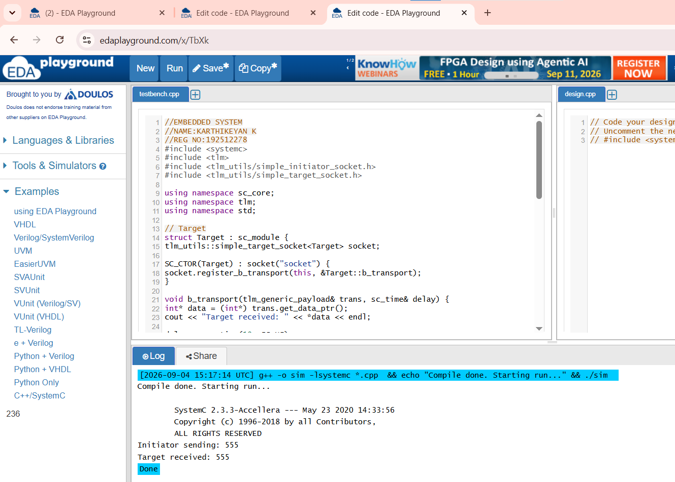
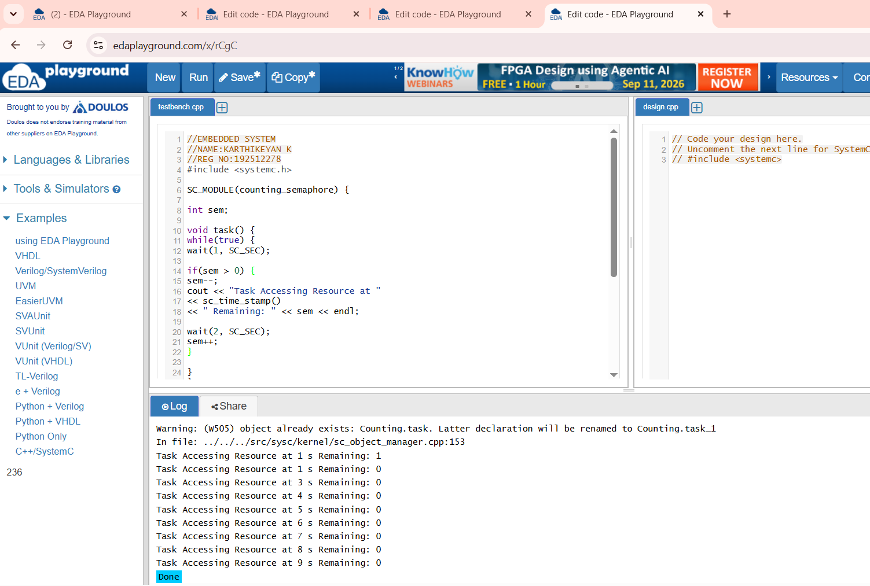
28 Counting Semaphore in SystemC

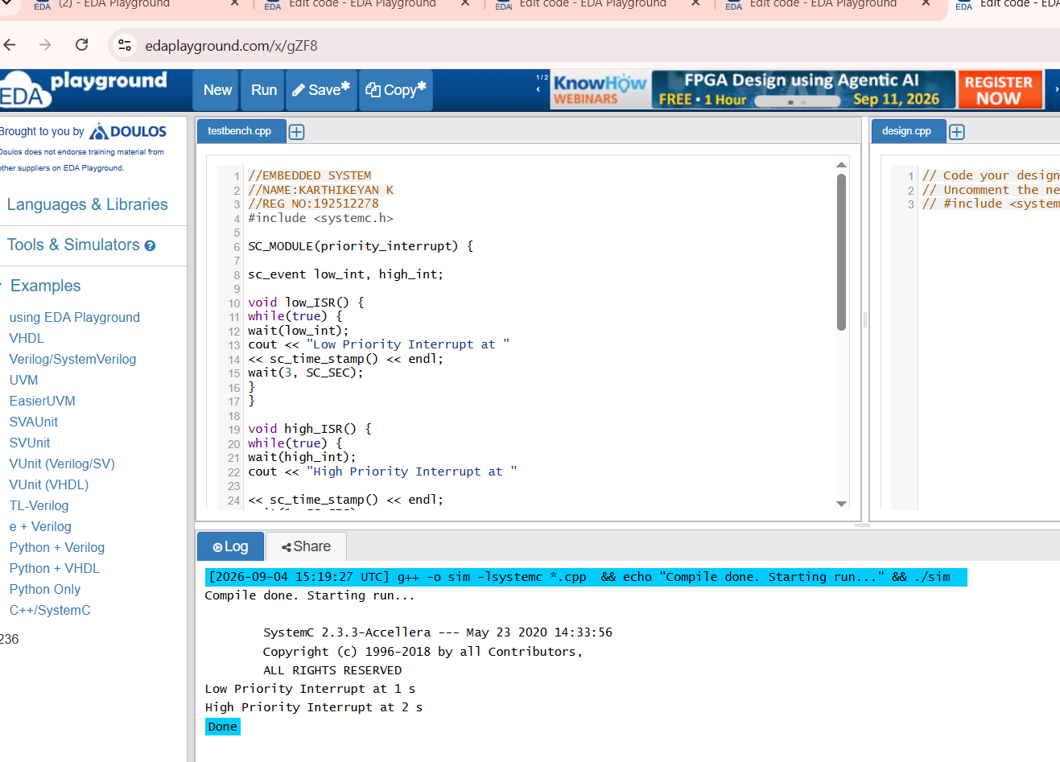
29 Priority-Based Interrupt Handling

30 RTOS Task Scheduling
